EC479

Auctions

Working Paper

Kebing Li

Is there a patriotism premium in ancient Chinese art auction market?

1. Introduction

The determinants of the final selling prices of artworks in art auction markets has long fascinated economists.[1] Many theories have been developed to try to capture the different factors that can affect either bidders’ behaviors or the sellers’ behaviors. In a paper focusing on anchoring effects, which are the cognitive bias that describes the common tendency to rely too heavily on the first piece of information offered when making decisions, Beggs and Graddy (2009) finds evidences from art auctions indicating the final selling prices are affected by anchoring effects on buyers, sellers, and even auctioneers. By showing effects of external factors on selling prices, this research therefore opens a new window in art auction market for people to ask the question: What other external factors can also possibly affect auction prices?

The term “external factors” is a bit vague here since it describes factors contributing to both common value and private values, while having nothing to do with the internal value of the artwork itself. A similar idea of an external factor has been developed in charity auction. Elfenbein and McManus (2010) build up a model using charity auction data and show that consumers tend to bid higher for charity-related products, which will provide them a sense of “warm glow”, which they refer to as a “charity premium” adding on to the interval value of the item that is being auctioned off.

Inspired from the idea of “charity premium”, I have been thinking of any parallel external factors that may play significant roles in art auctions. Consider an event that happened during a YSL (Yvette-Saint-Lawrence) spring art auction in France when a Chinese bidder refused to pay what he bid for an ancient Chinese artwork because he claimed the item was stolen from China and should be given back to the Chinese people at no cost.[2] This story shocked me since I never imagined that patriotism could play such a role in art auction setting. In another instance, reports had shown that wealthy Chinese buyers had been constantly buying back stolen Chinese artworks from foreign auctions to express their sense of patriotism and led to a huge boom in Chinese art auction market prices.[3]

However, while the size of the Chinese art auction market has significantly increased in past few years as more extremely wealthy Chinese buyers entered the market, the possible relationship between the increase in selling prices and the sense of patriotism that might actually drive those buyers to bid more has not been considered. I seek to investigate a “patriotism premium”, which describes the difference between the selling price of an artwork and its internal value, which I attribute to patriotism, an external factor that brings the sense of fulfillment to the buyers. The name of this term is intentionally designed to be parallel with the term “charity premium” mentioned above since both of them are essentially measuring a type of willingness to pay more than your valuation for the good but only under different contexts. The core of this paper, is to test if this “patriotism premium” exists, i.e can the price premium in art auctions be attributed to patriotism?

As the largest and most influential art auction market in the world, we will use the U.S.market as the setting to study the political tensions. To quantify patriotism effect, we will use measurements on political tensions to be our patriotism estimator since the sense of patriotism would rise when political tensions grew. Since ancient Chinese artworks, most of which are considered stolen or illegally exported from their original country, are most likely to trigger people’s sense of patriotism, we will therefore use them as the auction items. Hence, I will focus on evaluating whether Sino-US relations would affect the price of ancient Chinese painting in major art auctions.

The rest of the paper is organized as follows. Section 2 will review some previous literature on the related topics. Section 3 will define explicitely the idea of a “patriotism premium” including how to appropriately measure it, and will introduce some basic methodology used in this paper. Section 4 will discuss data used in my empirical analysis, including the auction data and the patriotism-measurement data. Section 5 provides some empirical models trying to test whether such a “patriotism premium” actually exists. Section 6 concludes.

1. Previous Literature Review

Since very few people have linked political factors with the prices for ancient art, my research question has really not been considered explicitly. Richard Kraus (2009) writes the only published paper that touches upon this issue of patriotism affecting selling prices, but the main focus of his paper is on introducing the historic context of China’s lost treasures and evaluating the reasons why Chinese people were so desperate with acquiring those artworks back. Author () considered[4] the relationship between the art world and the China-US trade war but he focuses more on the political rather than economic implications. Others[5] also discuss the fact that many wealthy Chinese people and corporations are bringing lost and stolen artworks back home by interviewing several winning bidders, but neither of them does any further analysis on the relationship between these people and the overall trend of selling price inflation in the market.

Some researchers have proposed theories and made observations associated with Chinese art auction markets and Chinese buyers. Some reports[6] have shown evidences suggesting an overall price inflation in art auction markets since Chinese buyers entered. Major newspapers[7] also point out that the Chinese art auction market has grown quickly and become the largest foreign art market. An interesting study of the Chinese wine market by Masset, Weisskopf, Faye, and Le Fur (2016) shows that the wine market in China also has blown up as people become wealthier and tend to pay more attention to their life qualities. Therefore, one thing our paper has to be aware of is to avoid the impact of the overall upward trends in Chinese economy. Several papers also talk about the investment side of the Chinese art auction market. Kraeussl and Logher (2010) investigate art markets in Russia, China, and India art markets, and argue that the Chinese art market, with a negative beta and a negative risk return, would be a good investment option. Park, Ju, Liang, and Tu (2017) also treat artworks as good investment options and work on analyzing investment returns on those artworks under different conditions.

Our paper, hence, can perfectly fill the blank of this field in the literature and well serve as a quantitative explanation to the whole story.

1. The idea of Patriotism Premium

The term “patriotism premium” is the key of this paper, but it is actually a hypothesized term. What we know for now is that there exists certain price premiums in the ancient Chinese art auction market, so we want to see if the premiums are due to a sense of patriotism. To test whether the term “Patriotism Premium” is a misnomer or not, we have to first figure out the premium, and then try to understand the connection between this premium and some patriotism measures.

Unlike charity auction on Ebay, where every item has a relatively clear value and identical items can be listed on both charity and non-charity auctions, the fair value of an artwork is hard to measure since it will be a combination of a person’s private value and his perception of the common value of the item. Furthermore, no two art pieces are identical. Even similar work done by same artist can be valued completely differently due to factors like provenance and the life period when the author completed the art. Therefore, we have to come up with a way to estimate the fair value of an item in this market. In the paper on anchoring effects, the authors use attributes of the art, such as length, width, and provenance, to estimate the fair value of an artwork. Although this method seems appropriate in their setting, it doesn’t really help in our case since their method is focusing on the common value side, while in our case, we have to certainly pay a lot of attention to the private value aspect since the sense of patriotism will drive up a person’s private value on certain items. Fortunately, most art auction house provide a low estimate and a high estimate for each art piece they are about to sell. These estimates are public, so it will give some basic senses to the buyers about what the auction house thinks the fair value of an item should be. Even though these estimates may be interpreted differently by individuals and biased by psychological reasons[8], it is still beneficial to use them as an indication of a fair value of an artwork since when experts try to give out those estimates, they have already taken into account both common and private value aspects of the artwork. When estimating the value, the auction experts use previous selling price, market trends, price of similar artworks, and other common value measurements to give those estimates. Based on that, by providing a low and a high estimate, they allow certain price fluctuations happening within the threshold due to difference in private values. Therefore, we can view those estimates as reasonable reflections of the fair value of an artwork, and define the premiums to be the difference between the sale prices and the estimates.

In addition to quantifying the premiums, we have to come up with a way to measure the political relationship between the United States and China. I use the Economic Policy Uncertainty index constructed by Baker, Bloom, and Davis[9]. A huge component of their indices is calculated based on the number of keywords appearing in the target country’s major newspapers that express uncertainty on regulations, policies, or economic and political conditions. For example, the newspapers included in their USA index are *the Washington Post*, *the Los Angeles Times*, *Wall Street Journal*, *the Boston Globe*, *the Miami Herald*, *the Chicago Tribune*, *the San Francisco Chronicle*,  *the Dallas Morning News*, and *the Houston Chronicle.* However, the website only provides country specific measures rather than indices that capture the relations between two countries, as needed for measurement on US-China relations. Thus, we decide to incorporate the USA EPU (Economic Policy Uncertainty) index, the China EPU index, and the Global EPU Index into our model, while still looking for other ways to measure similar things. Unfortunately, not many direct political measurements have been developed, which forces us to consider some indirect ways of measurement. We decide to consider three macro indicators, the FDI (foreign direct investment) from US to China, the exchange rates between USD and CNY, and the net exports to China from US as alternative political measurements. We believe that these macro variables can somehow capture the ever changing relationship between the US and China from an international trade perspective. Although it remains unclear for now which one of these measurements can actually make significant impacts on the existence of the price premiums, we believe that adding these measures to the model is reasonable.

1. Data and Methodology

There are two main datasets we are going to use: the auction data and the political measurements data.

Our auction data contains low estimate, high estimate, selling price, sale location, artwork medium, and sale time. The first three variables are used to calculate the price premiums while the location and medium help us to test whether different selling locations and different artwork mediums will have different impacts on the premiums. The time data is also included for us to possibly control for time-specific factors.

Sotheby's, as one of the largest art auction houses around the world, publicizes results of its past auctions. Hosting ancient Chinese art auctions in New York and Hong Kong every year makes Sotheby's our ideal data source, and therefore, our data is, directly and manually acquired from Sotheby's website[10], which presents all the information we want.

The macroeconomic data we are using includes the USA EPU index, China EPU index, Global EPU index, FDI from US to China, the exchange rates, and the net exports to China from US.

In order to argue that there exists some external factors in ancient Chinese art auction market, we compare the art market average premium, which is measured in the paper “Are Art Auctions Estimates Biased” by Ekelund, Jachson, and Tollison in 2013[11], with the Chinese art premium from 2000 to 2017. Figure 1 shows that even the low estimate premiums are far above the market average premiums. Chart 1 to Chart 3 provides a more straightforward way to see the fact that at least half of the time the ancient Chinese art auction premiums are higher than the market average. Therefore, we want to move forward to use empirical models to further evaluate the driven factors of such high premiums.

1. Empirical Analysis
   1. Figuring out the appropriate estimate to use

Before we move into regessions on premiums, we want to see which premium (low, mid,

and high) work out the best for the model. Figure 2 shows the result, which indicates that high estimates are positively and significantly correlated with the selling prices, while to my surprise, low estimates are negatively and signifiantly correlated with the selling prices. An explanation for the usually unconvincing low estimates lies under the fact that auction houses are likely to do conservative forecasting, especially on low estimates because they want more bidders to participate into the bidding.

* 1. Figuring out which indicators to use

Similar to part(a), we want to figure out which indicator we should use to best measure

the political uncertainty. Since we want to use monthly data to enlarge our overall data points, exchange rates and foreign direct investment are inappropriate in our setting since the former one provides daily data while the latter one is always calculated yearly. Thus, we want to see which one of the three economic uncertainty indices works best. Figure 3-5 shows that both the Global and the China indices provide statistical significant results, but the US indicator doesn’t show strong relationship with the selling price. This result makes sense since most of the buyers who bid for ancient Chinese artworks are from China or are China-related, so the economic and political of China would be more influnetial to their decisions.

* 1. Within medium comparison

Having decided two primary variables, we want to see whether the medium of the

artwork will influence the results, and hence we conduct a within-medium regression. Figure 6 to Figure 8 show the results of paintings, potteries and ceramics, and jades and jewels. These results point out that only paintings tend to be relevant with the uncertainty indicator, while the two other mediums, potteries and ceramics, and jades and jewels, are less related to the changes in political conditions.

* 1. Within Location comparison

A natural hypothesis we have on location is that if the auction happens in Asia then the

price will tend to be more related to the uncertainty in China comparing to auctions happening in other places, including London, Amsterdam, and New York. When we test this hypothesis, Figure 9 and Figure 10 combined validate our guess, in which the selling prices of artworks in Asia area (Figure 9) is strongly and significantly positive related to the uncertatiny indicator while outside Asia area (Figure 10) is not.

* 1. The Effect of month

Although we want to eliminate the time trend effects by conducting within year comparison, the small number of the dataset prevents us from getting significant results from it. Therefore, instead of looking year-specific effect, we try to understand the effect of month on the selling price. Figure 11 shows that month is not a significant factor affecting selling prices.

1. Conclusion

From the results above, we could see that China’s political uncertainty, medium of the

artwork, and the location where the auction took place matter, while sale month and US political uncertainty don’t have significant impact on selling prices. Also, because we don’t have data for a long period of time, for example 40 years, and we can hardly find out meaningful confounding variables, we can only conclude a correlationship rather than a causality between the patriotism effect and the selling premiums on Chinese ancient art auctions, which highlights the limitation of this research.

Reference

Ashenfelter, Orley, and Kathryn Graddy. "Sale Rates and Price Movements in Art Auctions." 2011. doi:10.3386/w16743.

"China's Antique and Art Auction Market up 13 Pct in 2016." Profile: Peru's Engineer-turned-president Martin Vizcarra - Xinhua | English.news.cn. March 29, 2017. Accessed December 20, 2018. http://www.xinhuanet.com/english/2017-03/29/c_136168628.htm.

Ekelund, Robert B., John D. Jackson, and Robert D. Tollison. "Are Art Auction Estimates Biased?" *Southern Economic Journal*80, no. 2 (2013): 454-65. doi:10.4284/0038-4038-2012.087.

"Global Economic Policy Uncertainty Index." Economic Policy Uncertainty Index. Accessed December 20, 2018. http://www.policyuncertainty.com/global_monthly.html.

Keegan, Matthew. "Wealthy Collectors Bring China's Lost and Stolen Artwork Back Home." Culture Trip. August 09, 2017. Accessed December 20, 2018. https://theculturetrip.com/asia/china/articles/wealthy-collectors-bring-chinas-lost-and-stolen-artwork-back-home.

Kraus, Richard Curt. "The Repatriation of Plundered Chinese Art." *The China Quarterly*199 (2009): 837. doi:10.1017/s030574100999052x.

Kuhn, Anthony. "Buying Back China's Lost Art Treasures." NPR. February 22, 2006. Accessed December 20, 2018. https://www.npr.org/templates/story/story.php?storyId=5228964.

Partington, Richard. "Art Prices at 'obscene' Levels as Chinese Join High-spending Elite." The Guardian. May 19, 2018. Accessed December 20, 2018. https://www.theguardian.com/artanddesign/2018/may/19/art-market-rising-prices-modigliani-hockney.

"Results." Steichen, Edward 'the Pon ||| Photographs ||| Sotheby's N08165lot387hmen. Accessed December 20, 2018. http://www.sothebys.com/en/auctions/results.html.

Reyburn, Scott. "Market for Chinese Art Is Increasingly in China." The New York Times. March 25, 2016. Accessed December 20, 2018. https://www.nytimes.com/2016/03/28/arts/international/market-for-chinese-art-is-increasingly-in-china.html?mtrref=www.google.com.

Reyburn, Scott. "Will Art Become a Casualty of the U.S.-China Trade War?" The New York Times. August 24, 2018. Accessed December 20, 2018. https://www.nytimes.com/2018/08/24/arts/will-art-become-a-casualty-of-us-china-trade-war.html.

Tan, Huileng. "Chinese Investors Are Radically Changing the Art World - Here's What They're Buying." CNBC. December 28, 2017. Accessed December 20, 2018. https://www.cnbc.com/2017/12/27/chinese-investors-are-radically-changing-the-art-world--heres-what-theyre-buying.html.

"Trend Watch: Inflation Fueling Chinese Art Market." Jing Daily. May 16, 2016. Accessed December 20, 2018. https://jingdaily.com/trend-watch-inflation-fueling-chinese-art-market/.

Appendix

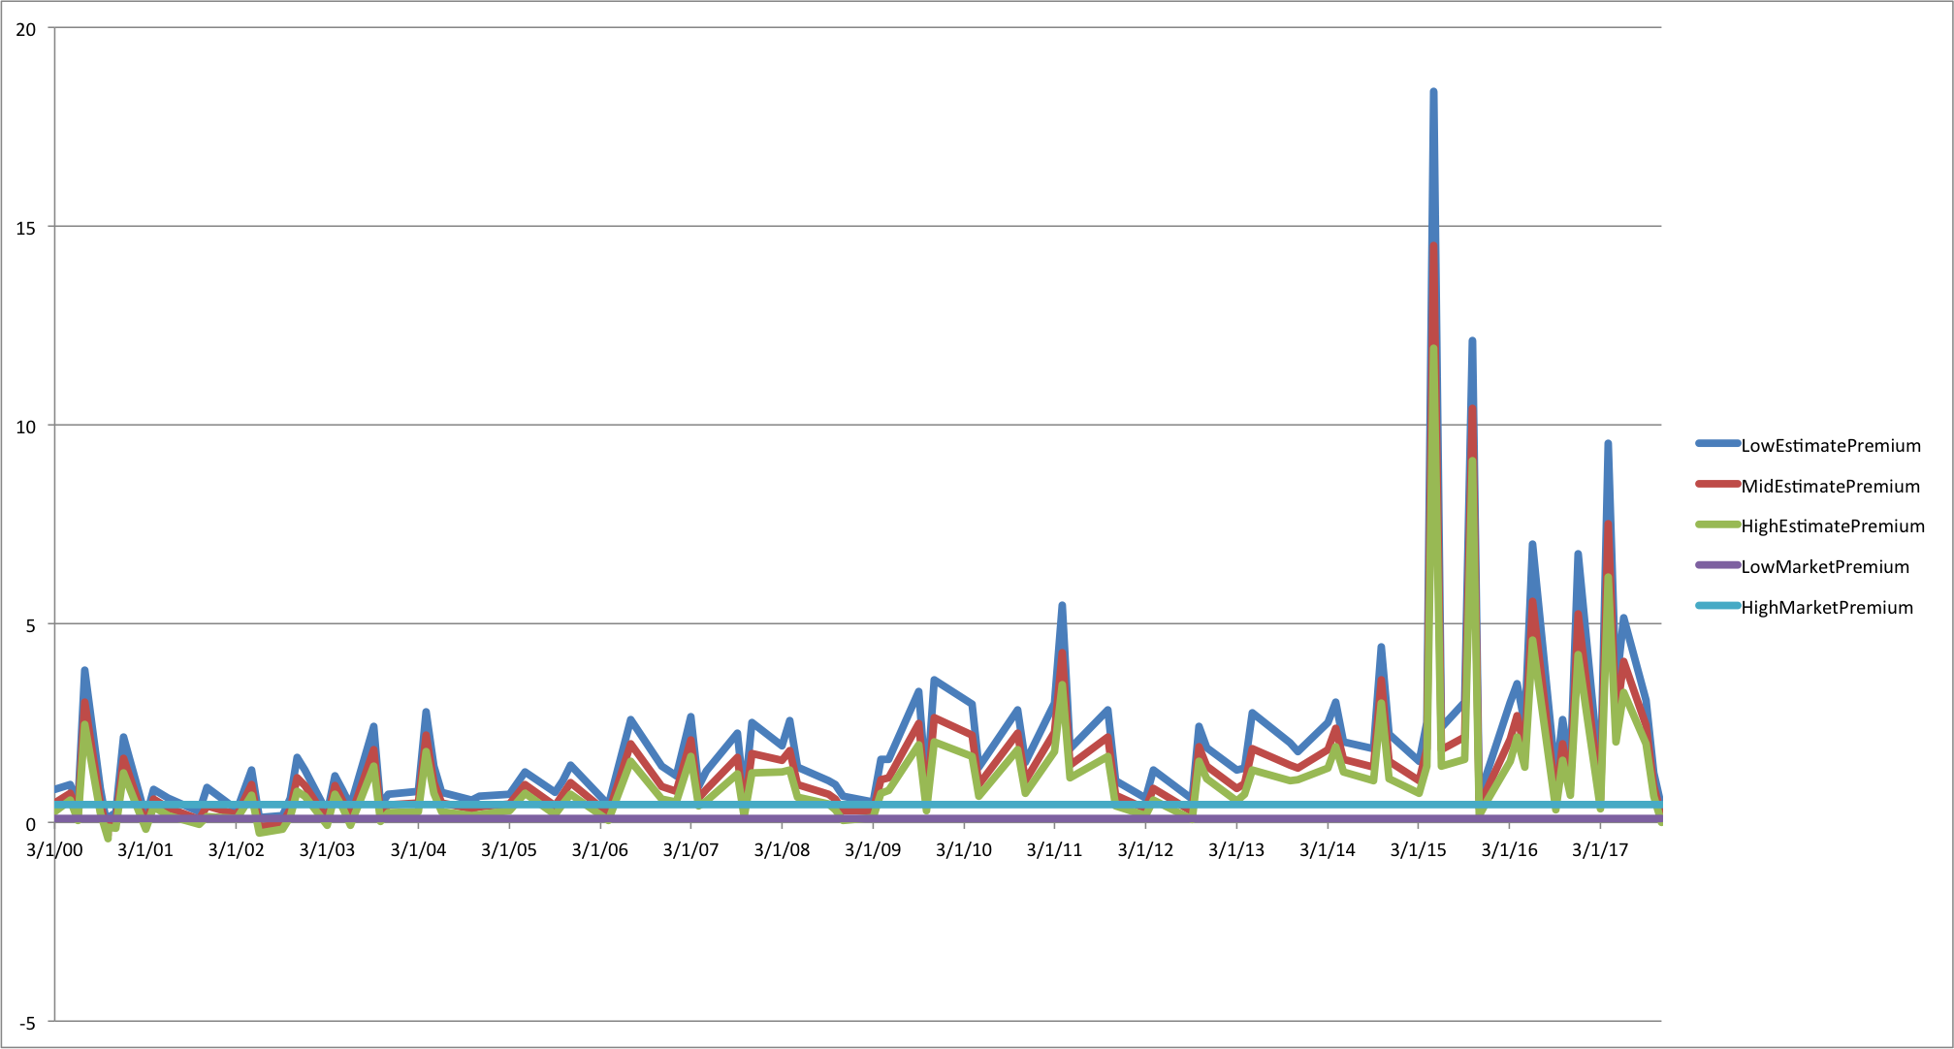

Figure 1

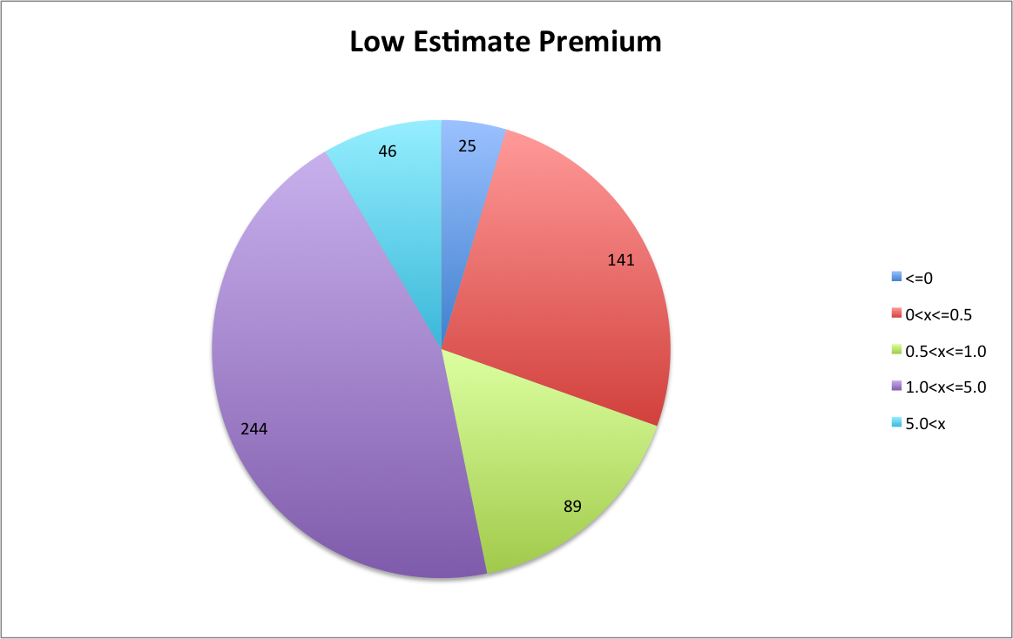

Chart1

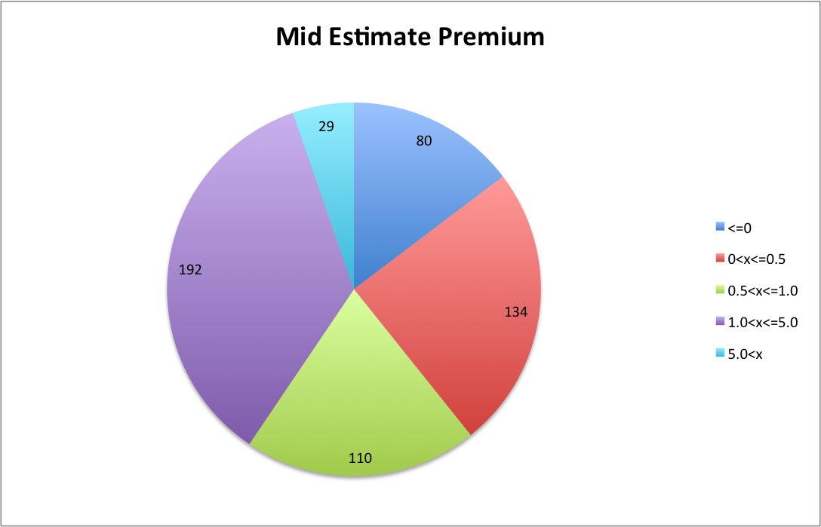

Chart 2

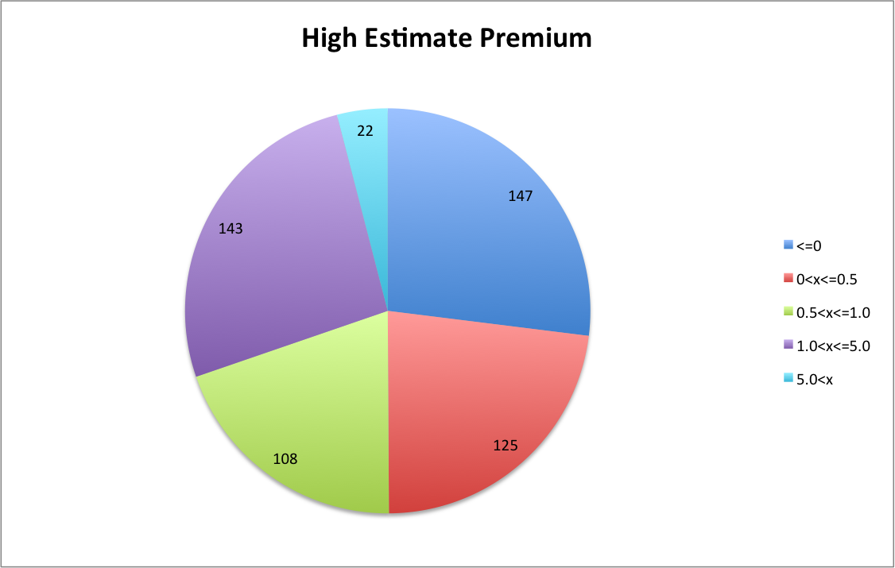

Chart 3

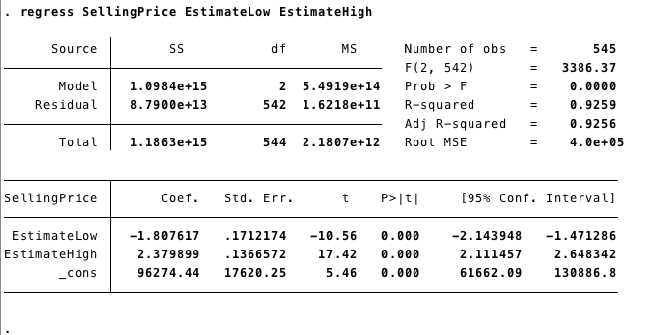

Figure 2

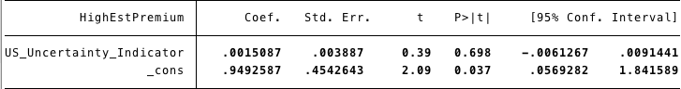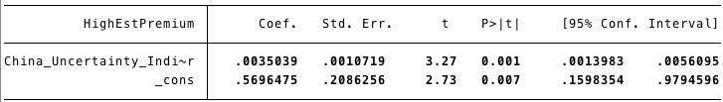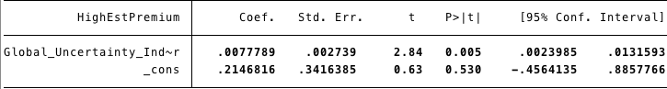

Figure 3-5

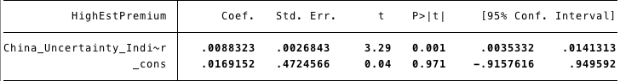

Figure 6

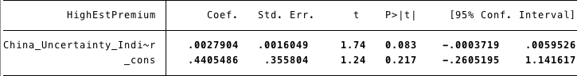

Figure 7

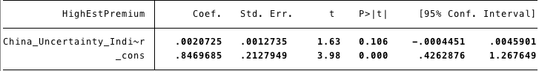

Figure 8

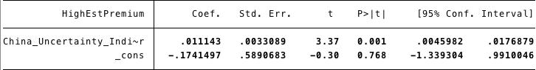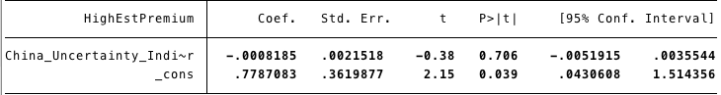

Figure 9-10

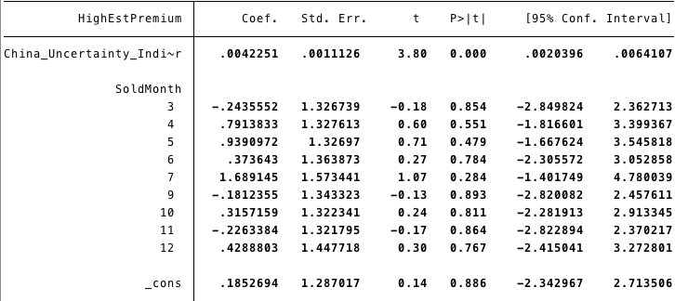

Figure 11

1. https://www.nber.org/papers/w16743
2. https://www.jstor.org/stable/23809543?seq=11#metadata_info_tab_contents
3. https://jingdaily.com/trend-watch-inflation-fueling-chinese-art-market/
4. https://www.nytimes.com/2018/08/24/arts/will-art-become-a-casualty-of-us-china-trade-war.html
5. https://theculturetrip.com/asia/china/articles/wealthy-collectors-bring-chinas-lost-and-stolen-artwork-back-home/https://www.npr.org/templates/story/story.php?storyId=5228964
6. https://www.theguardian.com/artanddesign/2018/may/19/art-market-rising-prices-modigliani-hockney
7. https://www.cnbc.com/2017/12/27/chinese-investors-are-radically-changing-the-art-world--heres-what-theyre-buying.html

   https://www.nytimes.com/2016/03/28/arts/international/market-for-chinese-art-is-increasingly-in-china.html?mtrref=www.google.com

   http://www.xinhuanet.com/english/2017-03/29/c_136168628.htm
8. https://www.jstor.org/stable/23809543?seq=11#metadata_info_tab_contents
9. http://www.policyuncertainty.com/global_monthly.html
10. http://www.sothebys.com/en/auctions/results.html
11. https://www.jstor.org/stable/23809543?seq=11#metadata_info_tab_contents